False Bay Literature Review

Contents

1 Surrounding Waters – Regional influences 1

2 Physical Characteristics of False Bay 1

2.1 Bathymetry and Surrounding Topography 1

2.2 Wind Climate 3

2.3 Wave Climate 8

2.4 Large scale climate variability 10

2.5 Circulation 11

2.6 Density Structure 11

3 Bibliography 13

# Surrounding Waters – Regional influences

“At the mouth of the Bay, along a line joining Cape Point to Cape Hangklip, a set of finite and time dependent boundary conditions must operate, particularly near Cape Point where the shelf drops off steeply and there is immediate exposure to events in the open ocean and on the Agulhas Bank (Largier and Swart 1987, Nelson and Polito 1987). The effect will be to force circulation in False Bay in addition to the forcing by local wind stress over the Bay itself.”(Wainman et al., 1987)

# Physical Characteristics of False Bay

## Bathymetry and Surrounding Topography

False Bay is a square-shaped embayment on the southwest coast of South Africa. The central coordinates of the bay, as presented by Flemming (2024), are $34°{14.0}^{'}S$ and $18°39.0'E$ (Figure 1). The maximum meridional extension of the bay is ~35 km from northern shore to the latitude crossing Cape Hangklip to the south $(34°{23}^{'}S)$, while the zonal counterpart is ~39 km between Fish Hoek and Gordon’s Bay (Flemming, 2024). The embayed area is approximately $1130 km^{2}$ (Flemming, 2024).

The average depth is ~41 m and the deepest point near the entrance is ~90 m (TALJAARD 2000). The bay is open to the sea at its southern extent, which is defined by Cape Point and Cape Hangklip to the west and east respectively. The northern extent is defined by long sweeping beaches separated nearly halfway by the eroding cliffs found from Kapteinsklip to Swartklip. The boulders and cliffs of the predominantly rocky eastern and western shores are interspersed with small sandy beaches. Mountain Group Sandstone and Malmesbury Group Shale (Flemming, 2024).

Figure ) The bathymetry of False Bay and the names of well-known locations and features. The blue cross indicates the centre of the bay (From Flemming, 2024; based on Glass, 1976)

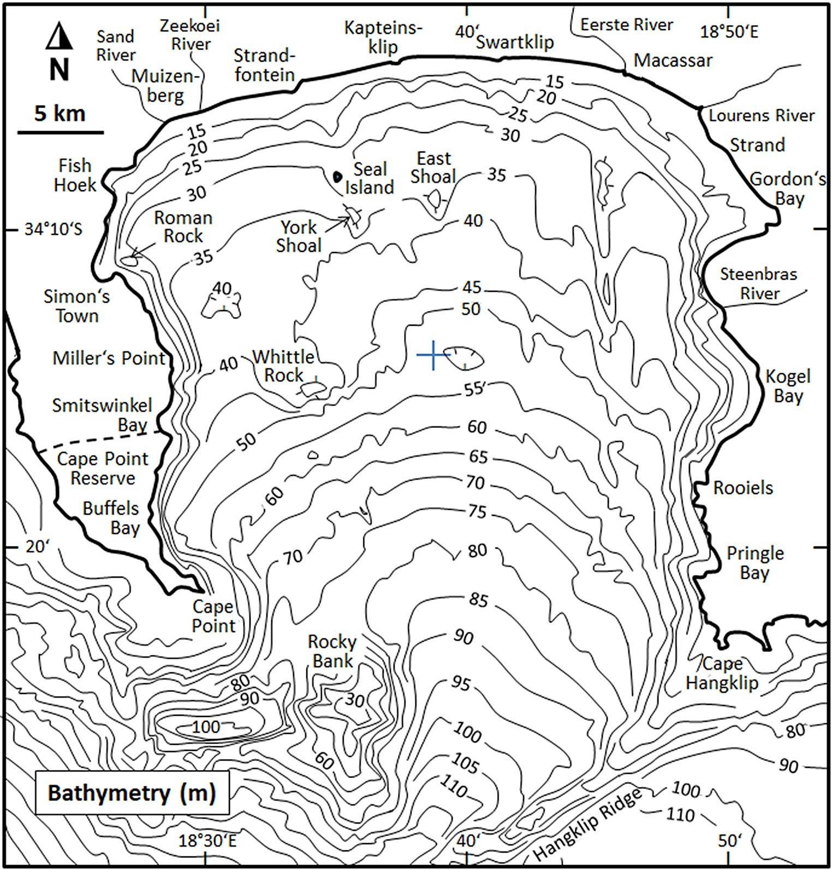

The bay has been split into four geographical zones which categorize sectors of the bay with similar bathymetric features (Atkins, 1970a). The northern sector is categorized by a gentle slope (~1:400) with a fragmented rocky bottom to the west and a predominantly sandy bottom to the east (Mallory, 1970). The bathymetry on the eastern and western peripheries of the bay is markedly steep (Fig. 1).The west zone is characterized by several large rocky features listed here from north to south: Roman Rock, Seal Island & York Shoal, East Shoal, Whittle Rock and Rocky Bank (Mallory, 1970). These features are a mix of granite and sandstone and form part of the Cape Granite and Table Mountain Group of geological formations (Flemming, 2024). The eastern side is characterized by long N-S running ridges, some of which are ~17 km long and ~300 m wide (Mallory, 1970). These ridges are comprised of shale and form part of the Malmesbury Group (Flemming, 2024). Two distinct terraces, one between 30 and 45 m, the other between 50 and 55 m, exist in the bay and are indicative of Pleistocene (2.6 Ma to 11 700 ka) sea-level stillstands (Flemming, 2024).

Given this pre-historic context, the bay itself can be seen as the southernmost extension of the Cape Flats, a sandy valley which links the Cape Peninsula on the west to the mainland on the east. The eastern side of the bay is rimmed by the mountainous inland terrain of the Hottentots Holland Mountains, with relatively high ranges of between 1100 and 1400 m (Bonnardot et al., 2005). The Cape Peninsula mountain range belts the bay to the west and has a slightly lower range of between 600 and 1100 m (Jury, 1991). The intricate orography of the terrain is shown in Fig 2. The orography controls the wind field over the area under the varying wind regimes and creates wind shadows in the lee of the mountains (Jury, 1991).

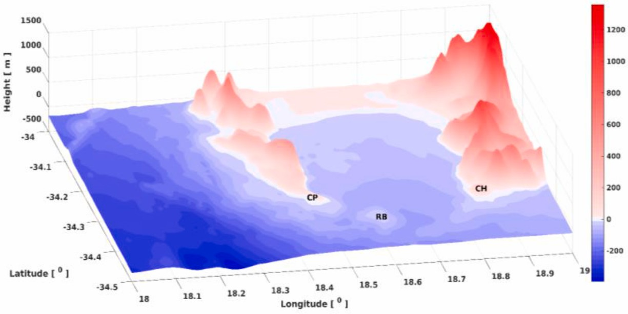

Figure ) Bathymetry and orography of False Bay. Cape Point (CP), Rocky Bank (RB) and Cape Hangklip (CH) are shown (From Daniels et al., 2022).

## Wind Climate

South African weather is primarily seasonal and dominated by large scale synoptic circulations which result from the interactions between the South Atlantic high pressure cell (SAH) and mid-latitude pressure systems that are associated with the upper-level westerlies. Wind over the bay is controlled by two main factors, the first being the nature and time scale of synoptic weather systems akin to the region, the second being the orography which leads to orographically sheared winds being common (Gründlingh et al., 1989; Jury et al., 1985) The eastward propagation of atmospheric Rossby waves and associated fronts over the Southern Ocean is the major control on the synoptic systems experienced in False Bay (Gründlingh et al., 1989; MacHutchon, 2006; Wainman et al., 1987).

Several synoptic types exist and help explain general atmospheric circulation along the coast. The SAH guides Southern Ocean fronts north-westward to toward the South African coast (Gründlingh et al., 1989). Approaching cold fronts (Mid-latitude cyclones) can generate coastally trapped low pressure systems on the west coast, which propagate eastward as the front encroaches (Gill, 1977). These coastal lows are associated with warm, often strong, offshore Foehn (Berg) winds leading the system, and cool offshore winds trailing it (Gill, 1977). Cold fronts follow the passage of coastal lows and their approach is associated with north-westerly winds, followed by the rapid incursion of cold high latitude air masses after their passage (Gründlingh et al., 1989; Jury et al., 1985). Fronts are followed by southerly meridional flow along the pressure gradient west of the cyclone. A ridging SAH follows, leading to strong south-easterly conditions, especially in summer. These dynamics, typically cycle on a weekly basis (5-7 days) and are seasonal in nature (Gründlingh et al., 1989).

Cut-off lows (COLs) are a class of low pressure system that cross the South African coast ~11 times a year (Singleton and Reason, 2007). These systems become detached from the main jet stream and therefore move independently, sometimes becoming stationary (Singleton and Reason, 2007). Extreme wave conditions, with significant wave height and peak periods exceeding 10 m and 20 s respectively are associated with COLs (Boyd et al., 2014).

Cold fronts and coastal lows are often weaker during summer due to the southward shift of the Inter Tropical Convergence Zone. The opposite is true in winter. Summer cycles are characterised by 3-5 days of southeasterlies, where local orographic effects lead to winds speeds exceeding 30 kn at Cape Point (Le Roux, 1975). The height of the inversion layer (unstable atmospheric layer where temperature increases with height) , and by extension the vertical effect of surface winds, is modulated by the passage of these weather systems and can affect the flow and speed of the winds over the bay (Bonnardot et al., 2005; Daniels et al., 2022; Jury, 1991). The vertical extent of surface winds reaches a minimum during coastal lows, and can create a wind shadow in the lee of the eastern mountains surrounding False Bay (Jury et al., 1985; Wainman et al., 1987). This is likely the cause the pronounced slowdown of winds in the north-east of the bay recorded during June, July and August by Atkins (1970b).

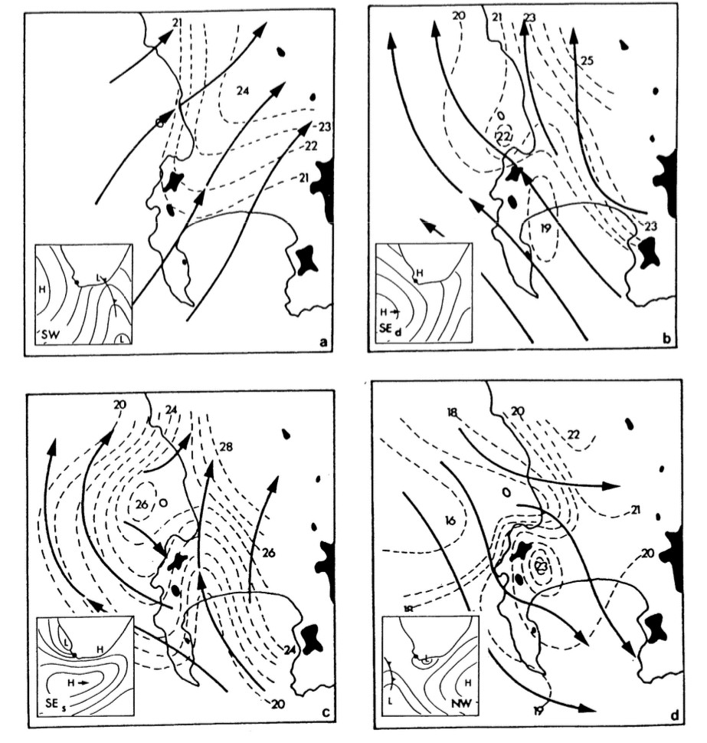

Figure ) Four wind phases and associated synoptic systems. Southerly meridional flow - a; Ridging SAH - b & c, Coastal low – d. Isobars show truncated values of MSLP in hPa (Jury, 1984).

The observed wind field in False Bay is highly variable and complicated. Wainman et al. (1987) analysed time series data from anemometers and found that correlations between stations was generally poor $\left(<0.6\right)$. The spatially varying wind field over False Bay was described as a synoptic sequence by Jury (1984):

**South-west regime:** Southwesterlies are associated with the ridging SAH following the passage of a cold front. Due to local orographic effects near Walker Bay (to the east of False Bay) the wind field becomes uniformly southerly and strengthens as the pressure gradients increase (Jury, 1984; Largier et al., 1992). This is illustrated in Fig 3a.

**South-east regimes**

**Deep** south-east regime: During southerly meridional flow deep southeasterlies flow over the surrounding mountain ranges and are associated with accelerated winds speeds across the bay, as well as the development of a strong easterly downslope jet in the lee of the Kogelberg mountains. Deep conditions are modified when a low level-level subsidence inversion (descending layer of air is heated as it is compressed near the surface) caps the southeasterlies below the mountain ranges to the east and west. This signals the development of the shallow south-east regime. This is illustrated in Fig 3b.

**Shallow** south-east regime: The ridging process of the SAH and lowers the height of the inversion layer and consequently blocks the surface wind from flowing over the Hottentots Holland mountain range. The mountain range and inversion constrain the wind to a ~600 m vertical extent, hence shallow, and deflect it seaward (Wainman et al., 1987). As a result of this the surface winds accelerate past Cape Hangklip and a wind shadow develops in the lee of the Helderberg Mountains, which impacts surface circulation near Gordon’s Bay (Wainman et al., 1987). The data analysed by Wainman et al. (1987) indicate that these winds entering the bay are deflected (likely by local orographic effects) to become increasingly southerly. The lowering of the inversion layer and subsequent change in the wind field usually occurs over three days (Jury, 1984; Jury et al., 1985) This process is illustrated in Fig 3c.

**North-west regime:** Northwesters signal the approach of a cold front after the passage of a coastal low. Flow over the Table Mountain range causes the wind to deflect to become more northerly over False Bay, where it blows uniformly. The winds at the mouth of the bay become stronger and more north-westerly to westerly due to topographic steering at Cape Point. This is illustrated in Fig 3d.

Fig. 4 shows the 10 m flow streamlines associated with each wind regime and is based on outputs from the South African Weather Service (SAWS) operational Unified Model which has a 4.4 km horizontal grid resolution (Brown et al., 2012; Cullen, 1993). The model output indicates that higher winds speeds are expected over the bay during south-west and deep south-east regimes, compared to slower speeds during the other two regimes. Average wind speed in the bay is~5-7 $m∙s^{-1}$ according to early observational studies by Le Roux (1975) and Gründlingh et al. (1989). These values correspond well to recent observations (Bonnardot et al., 2005; Daniels et al., 2022) and modelling studies (Coleman, 2019; de Vos, 2022; Salonen, 2019).

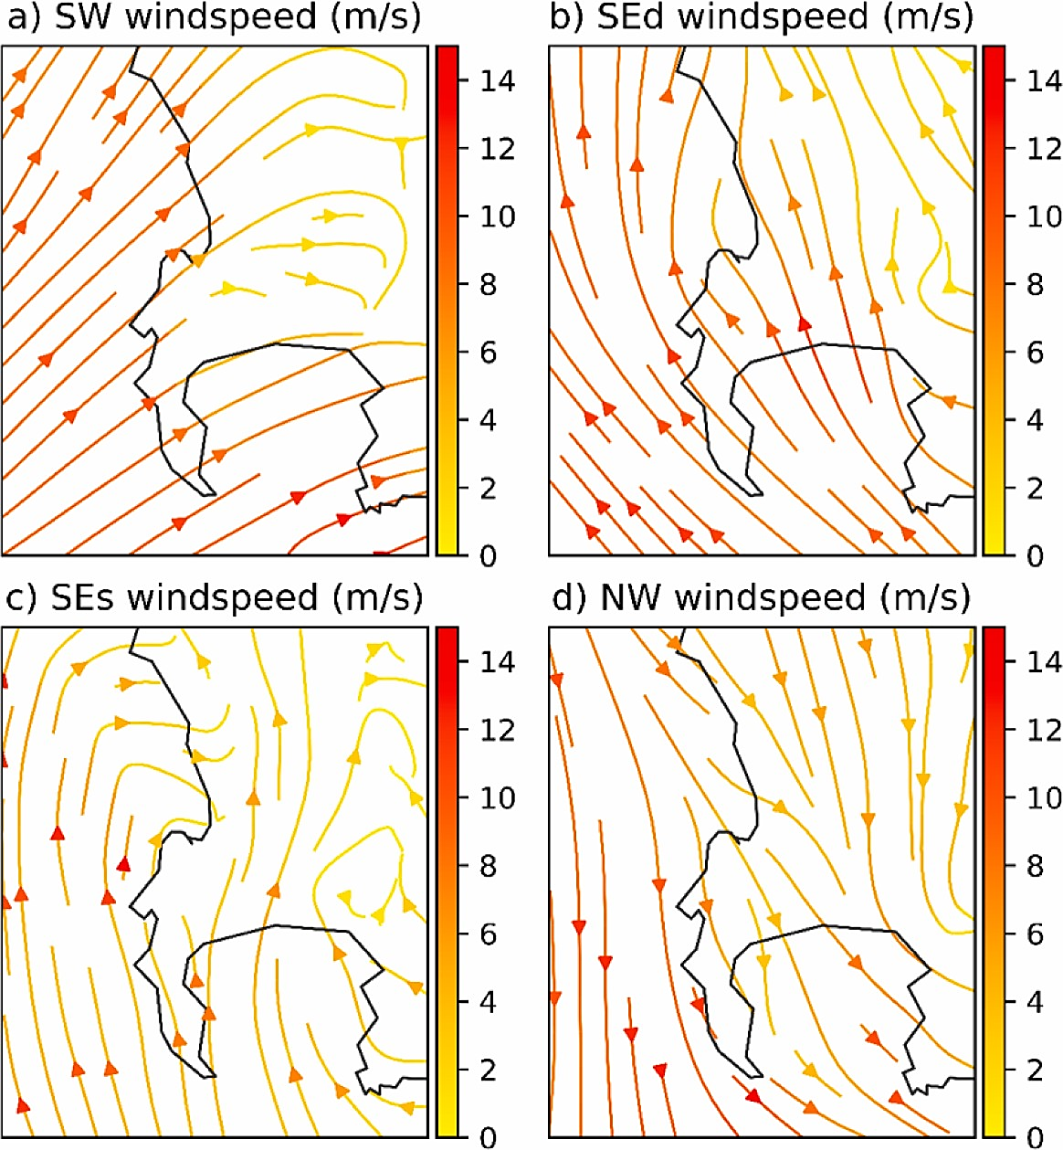

Figure ) Wind streamlines in $m∙s^{-1}$,for the four primary wind regimes that affect False Bay (From Daniels et al, 2022; after Jury, 1987)

## Wave Climate

Surface ocean waves result from an exchange of energy and momentum between the atmosphere and ocean. These surface waves grow in proportion to wind speed, fetch and duration (Ramos et al., 2021; Salonen, 2019)The wave systems which affect the South African coastline are primarily generated by eastward propagating cold fronts which originate in the South Atlantic and Southern Ocean.(Salonen, 2019; Shillington and Wyndham Harris, 1978). For this reason the predominant swell that affects False Bay comes from the southwest (Shillington and Wyndham Harris, 1978; Shipley, 1964).

The generation zones of swell waves are characterized by a broad wave spectrum (chaotic and spread over a wide range of frequencies and directions). Frequency and directional dispersion processes cause the wave spectrum to narrow, and so organised swell is formed (Veitch et al., 2019). The seasonal cycle of swell affecting False Bay is dependent on the spatio-temporal variability of seasonal cold fronts, which is linked to the seasonal variability of the upper-level westerlies (Taljaard et al., 1969; Veitch et al., 2019).

During austral summer (DJF), wave heights of between 2 and 3 m are normal, but anomalous northward occurrence of cold fronts can lead to larger seas (Joubert, 2008; Massel, 2017). A peak period of between 8 and 16 seconds is associated with the passage of cold fronts to the south of the Cape Point (van Verwolde, 2004).Greater wave heights of between 4 and 5 m are observed in winter months (JJA) (Massel, 2017). Cut-off lows

The Cape Point wave record is a long standing record of wave measurements that affect False Bay, with records split between a buoy at Slangkop (1980-1993) and Cape Point (1994-2010). It was maintained by the Council for Scientific and Industrial Research (CSIR) and Transnet. Veitch et al. (2018,2019) investigated wave parameters such as significant wave height $\left(H_{m0}\right)$ and peak period $(T_{p})$ and found a strong seasonal signal. The largest and higher period waves, carrying the most energy, reach the coast during the austral winter months (JJA) and carry a strong westerly component (Veitch et al., 2019).

Veitch et al. (2019) remarked that the seasonal cycle of waves is ‘consistent with’ the seasonal variation of the amount and depth of cold fronts in the South Atlantic and Atlantic section of the Southern Ocean. The wave generation zone moves closer to South Africa during austral winter due to the northward shift of the upper-level westerlies, leading to the greater observed $H_{mo}$ (Taljaard et al., 1969). Fig 5 shows the wave directions throughout the year with waves from the south-east being dominant(Veitch et al., 2019).

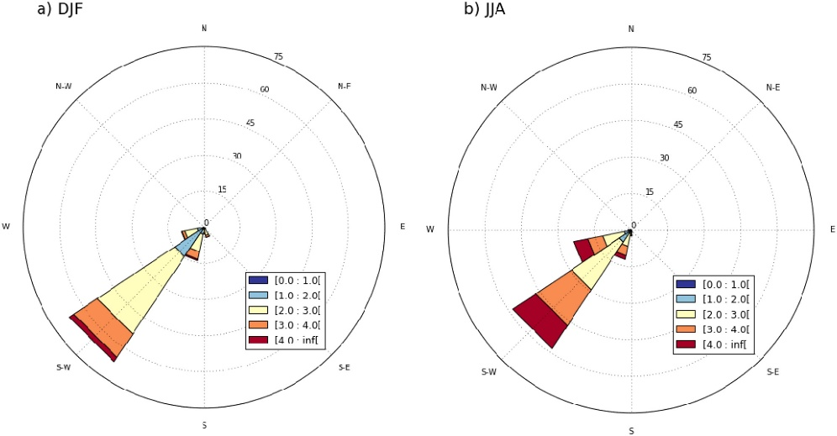

Figure ) Wave rose showing the observed mean wave direction $(\overline{θ})$ and significant wave height $(H_{m0})$ from the Cape Point wave record for the period from 2000 to 2010 (From Veitch et al., 2019).

Salonen (2019) generated seasonal wave roses (Fig 6) from the NCEP reanalysis and describes the mean wave direction affecting the bay to be between $210°$ and $240°$ true and the peak periods lie between 11.5 and 13.3 seconds. The observed wave parameters and those derived from the reanalysis product are in general agreement.

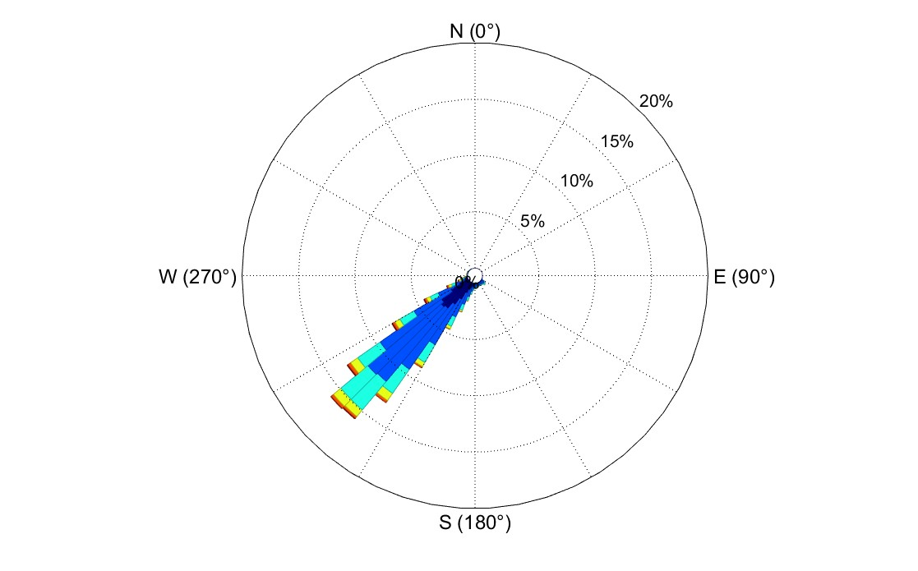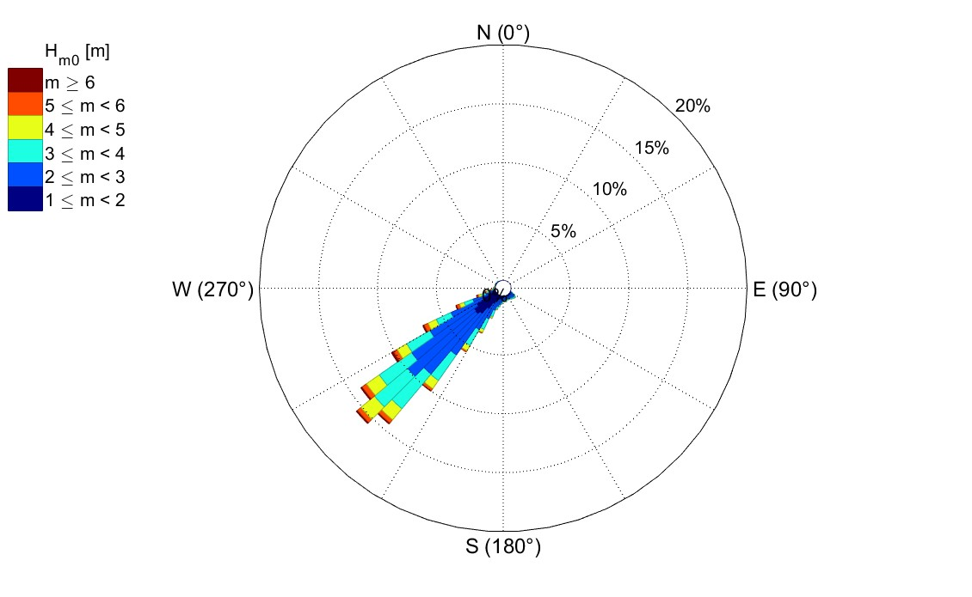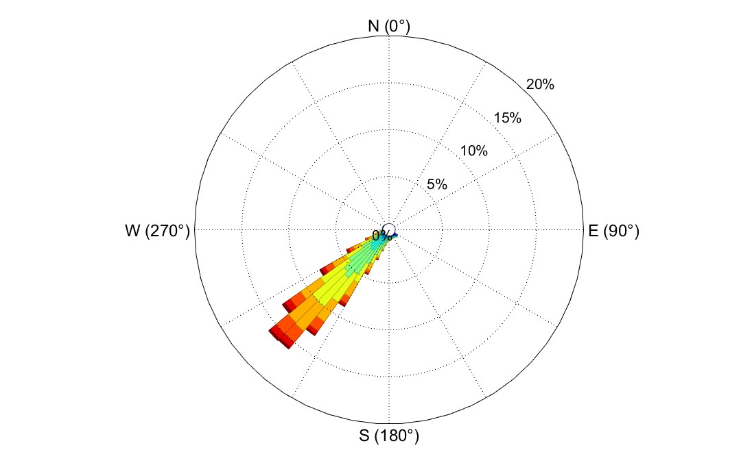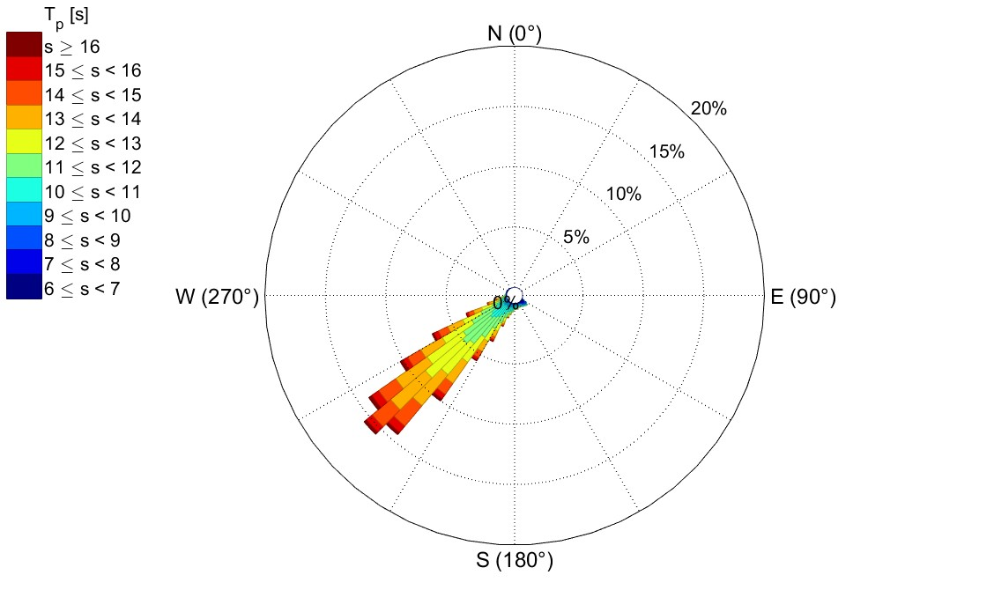

(a) *Hm*0 in summer (b) *Hm*0 in winter

(c) *Tp* in summer (d) *Tp* in winter

Figure ) Seasonal wave roses showing the mean wave directions from the NCEP reanalysis dataset (Kalnay et al., 1996) for a point outside of False Bay $(34.5° S, 18.5 ° E)$. Significant wave height proportions are shown as percentages are shown by roses a and b, whereas peak period is shown by roses c and d. Each rose shows the proportions associated with $5°$ bins (From Salonen, 2019)

The Cape Peninsula shelters the western side of the bay from the predominant south-west swell (Boyd et al., 2014; Salonen, 2019; Shipley, 1964).This blocking of wave energy leads to a nearly 2 m difference between wave heights observed inside and outside of the bay (Boyd et al., 2014). The eastern periphery generally experiences greater wave heights compared to the west (Boyd et al., 2014). Swell entering the bay has long been thought to be influenced by Rocky Bank, shown in Fig 7 (Shipley, 1946) and Salonen (2019) investigated this with a series of experiments using the Simulating Waves Nearshore (SWAN) model.

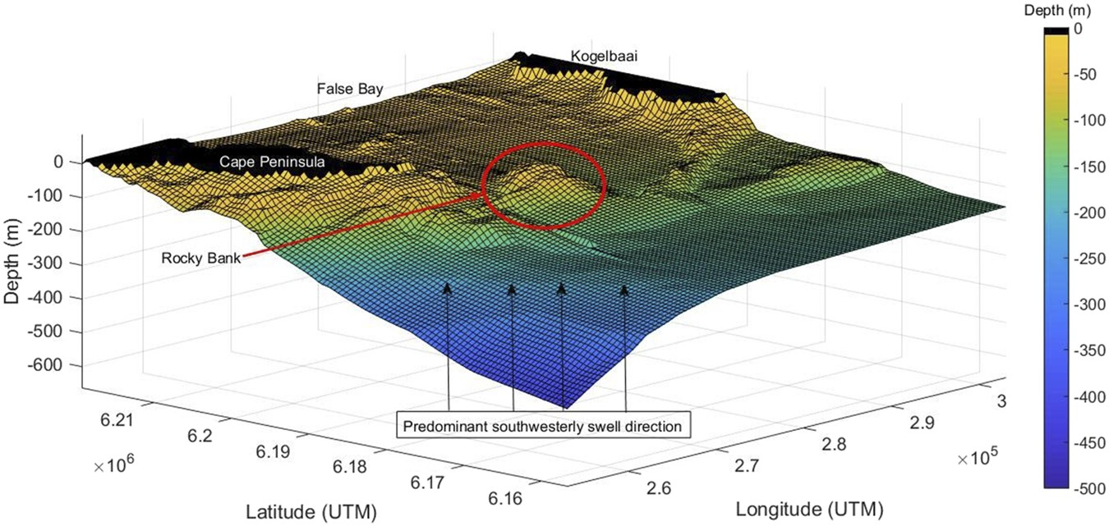

Figure 7) Three-dimensional visualisation of Rocky Bank. The viewing angle is consistent with the predominant swell direction (From Salonen and Rautenbach, 2021)

The main observation was the occurrence of convergent wave energy within the bay due to refraction and spatial focussing caused by Rocky Bank. This leads to an observed reduction in coastal wave heights in the lee of Rocky Bank. The reduction is amplified by increased peak periods. Peak periods greater than 12 seconds lead to a convergent wave refraction pattern and is indicative of the spatial focussing of wave energy by Rocky Bank. Salonen (2019) concluded that the eastern periphery of the bay, known as the “Death Coast” by local anglers, is exposed to the effects of spatial focussing and could experience waves large enough to cause accidents.

The bay is surrounded by local orographic features and semi-sheltered from the incoming swell. The importance of locally wind driven waves within embayments is made clear throughout the literature (Coleman, 2019; Daniels et al., 2022; de Vos, 2022; Jury, 1991; Salonen, 2019). Daniels et al (2022) set up experiments using the SWAN model forced by wind products of various resolutions (to capture orographic effects) to investigate the effects of local winds on waves and currents within the bay. The experiments confirmed that waves on the western periphery are mainly generated by local winds, rather than incoming swell. The eastern periphery is more exposed to the predominant swell, as discussed previously, and the wave field is only marginally influenced by local wind forcing. These findings are attributed to the high resolution wind field provided by the Wind Atlas of South Africa (WASA) product.

**Effects of other features? And waves on beaches?**

Internal waves

## Large scale climate variability

Energy transfers between the ocean and atmosphere are dynamic and involve complex processes that span all spatio-temporal scales (Ramos et al., 2021). Climate oscillations are known to influence sea level pressures as well as wind patterns, which in turn affects surface ocean waves (Hemer et al., 2010; Ramos et al., 2021). Few studies have looked into the role of these oscillations, and their effect on atmospheric circulation in the region of the South Atlantic.

Veitch et al. (2019) investigated the effects of El Niño Southern Oscillation (ENSO) and the Southern Annular Mode (SAM) on the intensity of and adjustment of mid-latitude cyclone tracks (cold fronts). This was paired with data from the Cape Point wave record to elucidate the effect on the wave climate. A positive (negative) ENSO is associated with a positive (negative) sea surface temperature anomaly in the central/eastern tropical Pacific. A positive (negative) SAM is associated with pressure gradient changes between the mid and high latitudes in the southern hemisphere. A positive (negative) westerly wind speed anomaly is associated with a poleward (equatorward) shift in storm tracks. A summary of Veitch et al. (2019)’s findings follow:

**Winter (JJA)**

The mean wave height was not related to ENSO or SAM. Mean wave direction changes to become more southerly, with a clear shift between 1980-1992 and 1994 -2006. The phase of SAM affected the frequency of extreme wave events, with a reduction (increase) during a positive (negative) SAM.

**Summer (DJF)**

Waves are generally smaller and more southerly. A negative (positive) SAM is associated with larger (smaller) more westerly (southerly) waves. A negative (positive) ENSO is associated with smaller (larger) more southerly (westerly) waves. The co-occurrence of a positive ENSO and negative SAM lead to an increase in westerly wave heights.

## Circulation

The circulation in False Bay is highly dynamic at sub-seasonal to decadal time scales and is alternate in nature (Dufois and Rouault, 2012).

Good summary in Daniels et al 2022

Wind dynamics are the primary driver of the mean circulation in False Bay, and are therefore seen as the main driver of the vertical temperature structure and stratification of the bay (Atkins, 1970a, 1970b; Dufois and Rouault, 2012; Gründlingh and Largier, 1988; Jury, 1991; Wainman et al., 1987)

Wind driven currents

Wave driven currents

Tidal currents

Subtidal currents

## Density Structure

Hydrodynamic modelling of False Bay indicates that Rocky Bank segregates warmer western water from colder eastern waters (Coleman, 2019). Bottom waters east of Rocky Bank are consistently (under well-mixed and stratified conditions) approximately 1-2 $°C$ colder than to its west (Coleman, 2019). Coleman’s (2019) model showed (given stratified conditions) that the north-westerly winds, usually associated with warmer months, cause cold offshore water to be advected into the centre of the bay.

# Bibliography

Atkins, G.R., 1970a. Thermal Structure and Salinity of False Bay. Trans. R. Soc. South Afr. 39, 117–128. https://doi.org/10.1080/00359197009519107

Atkins, G.R., 1970b. Winds and Current Patterns in False Bay. Trans. R. Soc. South Afr. 39, 139–148. https://doi.org/10.1080/00359197009519109

Bonnardot, V., Planchon, O., Cautenet, S., 2005. Sea breeze development under an offshore synoptic wind in the South-Western Cape and implications for the Stellenbosch wine-producing area. Theor. Appl. Climatol. 81, 203–218. https://doi.org/10.1007/s00704-004-0087-y

Boyd, A., Theron, A., Rossouw, M., Rautenbach, C., Saint, U., Maherry, A., August, M., 2014. Determination of the Inshore wave climate along the South African coast - Phase 1 for Coastal Hazard and Vulnerability Assessment.

Brown, A., Milton, S., Cullen, M., Golding, B., Mitchell, J., Shelly, A., 2012. Unified Modeling and Prediction of Weather and Climate: A 25-Year Journey. https://doi.org/10.1175/BAMS-D-12-00018.1

Coleman, F., 2019. The Development and Validation of a Hydrodynamic Model of False Bay (Master of Engineering). Stellenbosch University, South Africa.

Cullen, M.J.P., 1993. The unified forecast/climate model. Meteorological Office, Bracknell.

Daniels, T., Fearon, G., Vilaplana, A., Hewitson, B., Rautenbach, C., 2022. On the importance of wind generated waves in embayments with complex orographic features – A South African case study. Appl. Ocean Res. 128, 103355. https://doi.org/10.1016/j.apor.2022.103355

de Vos, M., 2022. Modelling waves and near-shore circulation around the Cape Peninsula: towards enhanced predictions for South African coastal activities (Doctor of Philosophy). University of Cape Town, South Africa.

Dufois, F., Rouault, M., 2012. Sea surface temperature in False Bay (South Africa): Towards a better understanding of its seasonal and inter-annual variability. Cont. Shelf Res. 43, 24–35. https://doi.org/10.1016/j.csr.2012.04.009

Flemming, B.W., 2024. Sedimentology of False Bay (Western Cape, South Africa): geological background information for the integrated environmental management of a physically confined coastal compartment. J. Coast. Conserv. 28, 1–23. https://doi.org/10.1007/s11852-024-01080-z

Gill, A.E., 1977. Coastally trapped waves in the atmosphere. Q. J. R. Meteorol. Soc. 103, 431–440.

Gründlingh, M.L., Hunter, I.T., Potgieter, E., 1989. Bottom currents at the entrance to False Bay, South Africa. Cont. Shelf Res. 9, 1029–1048. https://doi.org/10.1016/0278-4343(89)90056-3

Gründlingh, M.L., Largier, J.L., 1988. Physical oceanography in False Bay: A review. Suid-Afr. Tydskr. Vir Natuurwetenskap En Tegnol. 7, 133–143. https://doi.org/10.4102/satnt.v7i3.914

Hemer, M.A., Church, J.A., Hunter, J.R., 2010. Variability and trends in the directional wave climate of the Southern Hemisphere. Int. J. Climatol. 30, 475–491. https://doi.org/10.1002/joc.1900

Joubert, J.R., 2008. An investigation of the wave energy resource on the South African coast, focusing on the spatial distribution of the south west coast. Stellenbosch: University of Stellenbosch.

Jury, M.R., 1991. The weather of False Bay. Trans. R. Soc. South Afr. 47, 401–418.

Jury, M.R., 1984. Wind shear and differential upwelling along the SW tip of Africa. (Ph.D. thesis). University of Cape Town, South Africa.

Jury, M.R., Kamstra, F., Taunton-Clark, J., 1985. Diurnal wind cycles and upwelling off the northern portion of the Cape Peninsula in summer. South Afr. J. Mar. Sci. 3, 1–10. https://doi.org/10.2989/025776185784461216

Largier, J.L., Chapman, P., Peterson, W.T., Swart, V.P., 1992. The western Agulhas Bank: circulation, stratification and ecology. South Afr. J. Mar. Sci. 12, 319–339. https://doi.org/10.2989/02577619209504709

Le Roux, J.J., 1975. Climate of South Africa, Part 1: Surface winds. (Report WB No. 38). South African Weather Bureau, Dept. Transport, South Africa.

MacHutchon, K.R., 2006. The Characterisation of South African Sea Storms (Ph.D. thesis). Stellenbosch University, Stellenbosch: South Africa.

Mallory, J.K., 1970. The Bathymetry and Microrelief of False Bay. Trans. R. Soc. South Afr. 39, 109–112. https://doi.org/10.1080/00359197009519105

Massel, S.R., 2017. Ocean surface waves: their physics and prediction, 3rd ed. World scientific.

Ramos, M.S., Farina, L., Faria, S.H., Li, C., 2021. Relationships between large-scale climate modes and the South Atlantic Ocean wave climate. Prog. Oceanogr. 197, 102660. https://doi.org/10.1016/j.pocean.2021.102660

Salonen, N.M., 2019. Towards Rogue Wave Characterization in False Bay, South Africa.

Shillington, F.A., Wyndham Harris, T.F., 1978. Surface waves near Cape Town and their associated atmospheric pressure distributions over the South Atlantic. Dtsch. Hydrogr. Z. 31, 67–82. https://doi.org/10.1007/BF02227005

Shipley, A.M., 1964. Some aspects of wave refraction in False Bay. South Afr. J. Sci. 60, 115–120. https://doi.org/10.10520/AJA00382353_1513

Singleton, A.T., Reason, C.J.C., 2007. Variability in the characteristics of cut‐off low pressure systems over subtropical southern Africa. Int. J. Climatol. 27, 295–310. https://doi.org/10.1002/joc.1399

Taljaard, A.J., Crutcher, A.H., Jenne, A.R., Loon, A.H. van, Center, C.N.W.R., Defense, C.U.S.D. of, 1969. Climate of the Upper Air: Southern Hemisphere: Volume 1: Temperatures, Dew Points, and Heights at Selected Pressure Levels. https://n2t.org/ark:/85065/d7h131fh

van Verwolde, E., 2004. Characteristics of extreme wave events and the correlation between atmospheric conditions along the South African coast (Master’s Thesis). University of Cape Town, South Africa.

Veitch, J., Rautenbach, C., Hermes, J., Reason, C., 2019. The Cape Point wave record, extreme events and the role of large-scale modes of climate variability. J. Mar. Syst. 198, 103185. https://doi.org/10.1016/j.jmarsys.2019.103185

Wainman, C.K., Polito, A., Nelson, G., 1987. Winds and subsurface currents in the False Bay region, South Africa. South Afr. J. Mar. Sci. 5, 337–346. https://doi.org/10.2989/025776187784522423